E1-a
- Means of pre-test scores of the three methods are very similar to each other.
- The standard deviation of method A is the smallest among the three methods, while the standard deviation of method C is the largest.
- The numbers of participants are the same that were assigned to each method.
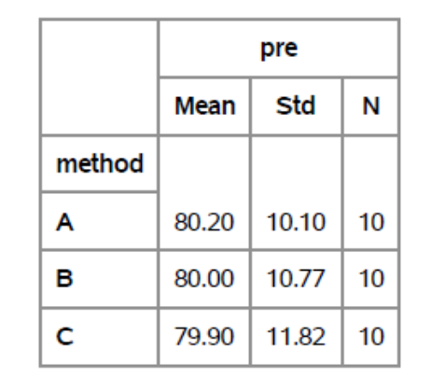

E1-b
- Means of post-test scores of the three methods are very different. Method A has the smallest mean post-test scores, while method C has the largest.
- Post-test scores under method B have the smallest standard deviation, while that under method A have the biggest standard deviation.
- Again, the numbers of participants are the same that were assigned to each method.
- Mean post-test scores under method A and B decreased compared with pre-test condition, while mean post-test score under method C increased.
- Standard deviations in all three groups decreased a lot compared with pre-test condition.
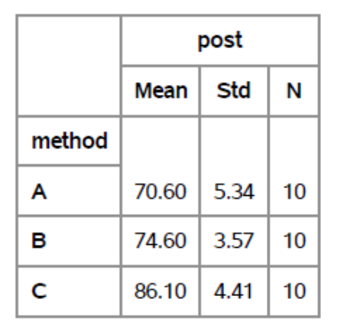

E2-a
It looks to me that there is a linear relationship between X and Y.

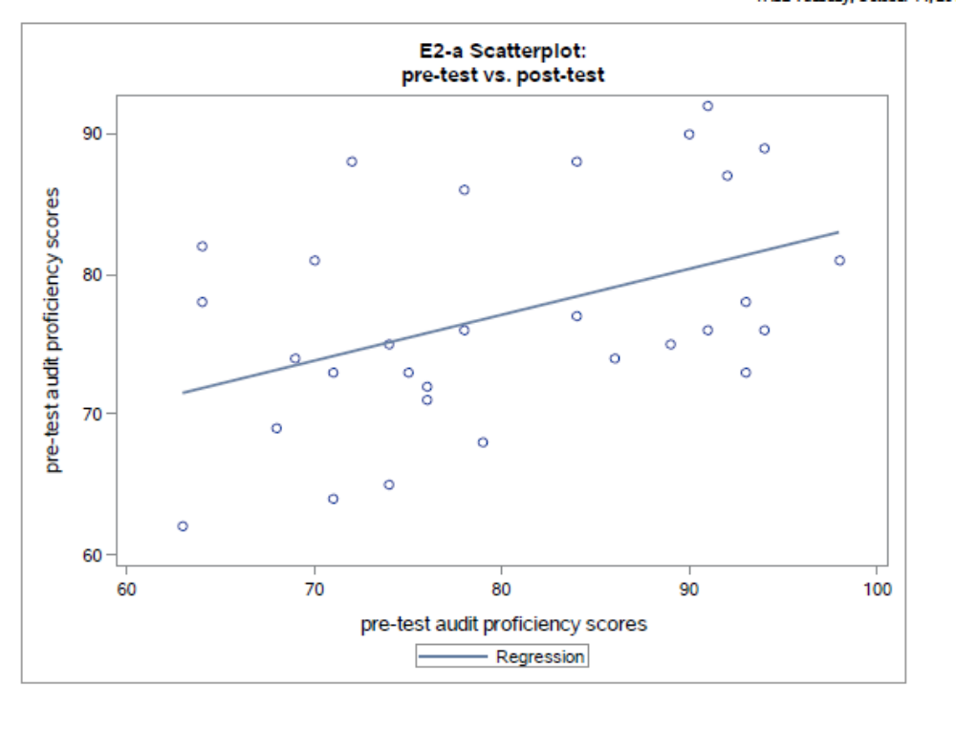

E2-b
I obtained the Pearson correlation coefficient between pre and post-test scores. The correlation between pre and post-test scores is .63, and the p-value is smaller than .05, which indicates that pre and post-test scores have a significantly positive correlation.

This notable correlation between the DV and the covariate indicates that pre-test score could be a reasonable covariate.

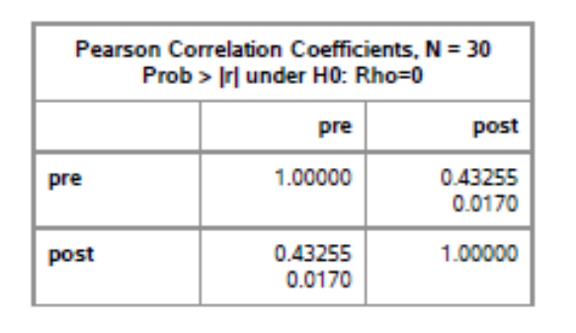

E2-c
According to the graph below, it looks like the slopes of regression lines for method B and method C are pretty parallel. Even though the regression line for method A is not parallel to that of method B, they do not cross within the range of the X axis. The regression line for method A does not cross that of method C, either. It is quite possible that the interaction effects between pre-test and method are not statistically significant. Therefore, it looks to me that the parallel slopes assumption is reasonable.

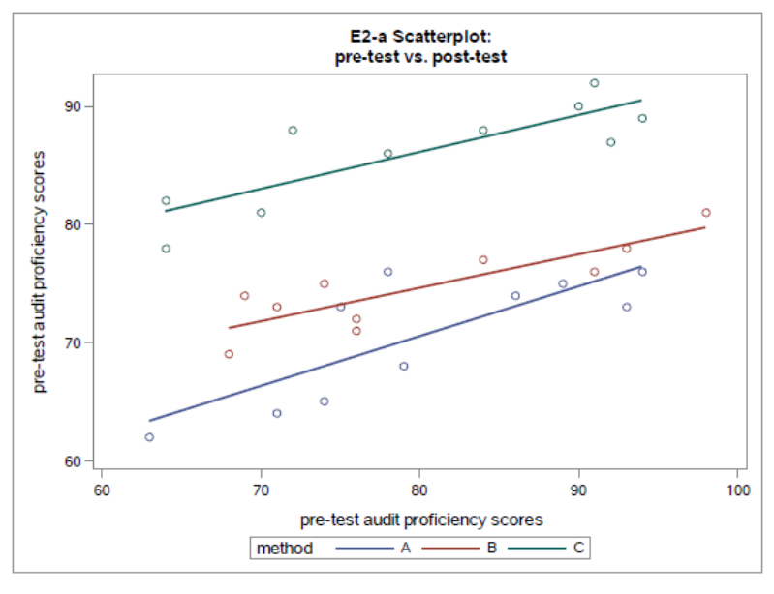
E3-a
According to the tables below, the one-way ANOVA shows that there’s no statistically significant difference between the means of pre-test scores across different levels of methods (F=0.00, p-value = .9980), and that is to say the pre-test scores are independent of methods. Therefore, this assumption of ANCOVA models is met.
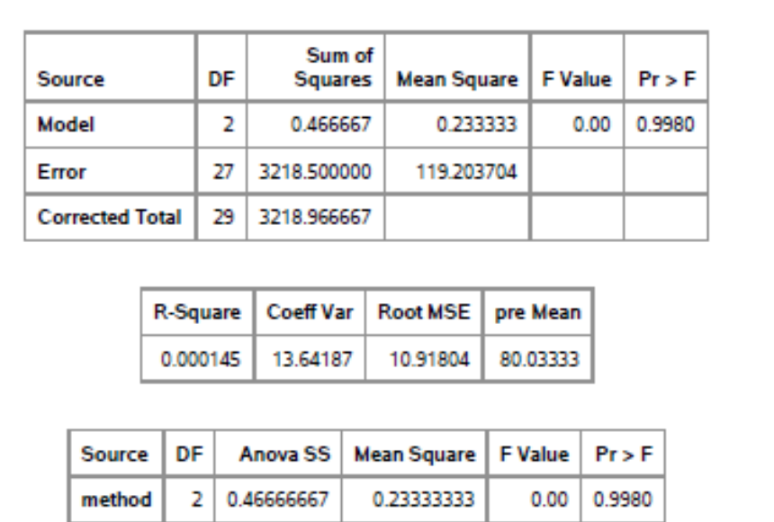

E3-b
- According to E2-a, there’s a linear relationship between X and Y.
- According to E2-b, there’s a significant correlation between X and Y, indicating that X could be a reasonable covariate.
- According to E2-c, the assumption of homogeneity of regression slopes is met.
- According to E3-a, the assumption of independence of the covariate and treatment effect is met.
- Therefore, the ANCOVA model seems appropriate for the data.

E4-a
According to the tables below, training type has a statistically significant main effect on post-test scores (F= 32.04, p-value< .0001).

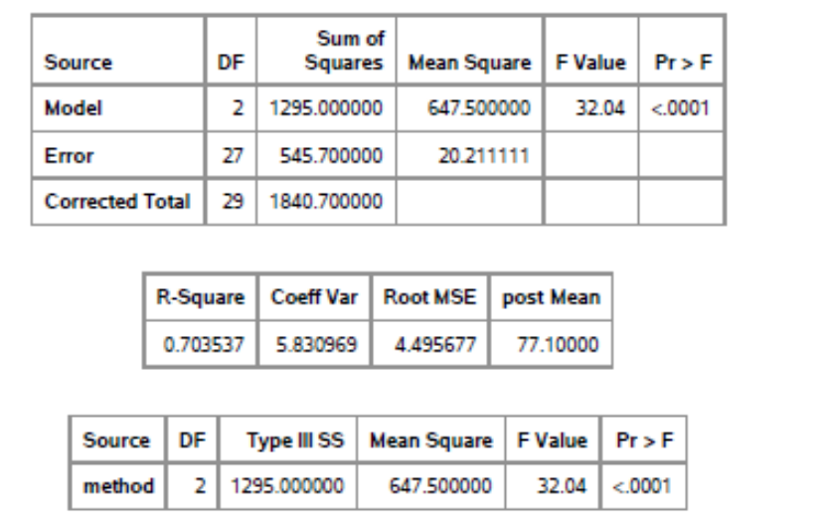

E4-b
According to tables and the graph below, method A and method B do not have significant pairwise mean difference. Method A and method C as well method B and method C have significant pairwise mean difference.

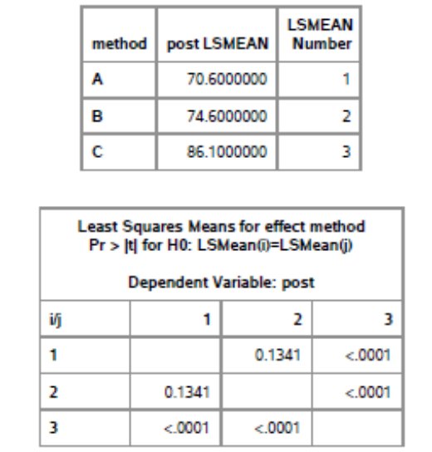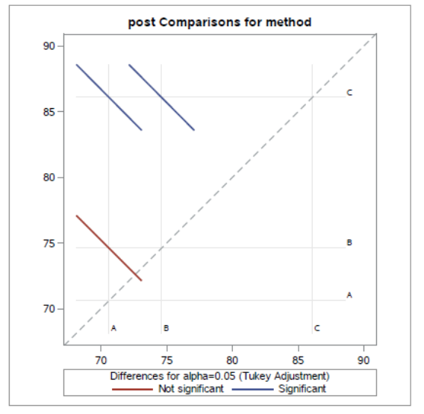

E5-a
According to the tables below, the model with X (pre-test scores), methods as predictors, account for a significant proportion of Y (post-test scores), because the p-value is smaller than .0001 (F=76.77). Also, the value of R-square given in the table below means approximately 90% of the variance in Y (post-test scores) is accounted for by the model.
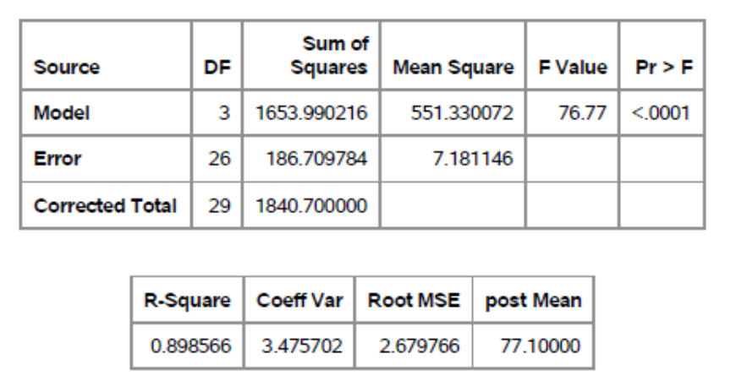
E5-b
According to the Type I SS test, the main effect of pre-test scores is statistically significant given that no other predictors are in the model (F=47.96, p-value <.0001).

E5-c
According to the Type I SS test, the main effect of method is statistically significant given that pre-test scores is included in the model (F=91.18, p-value<.0001).

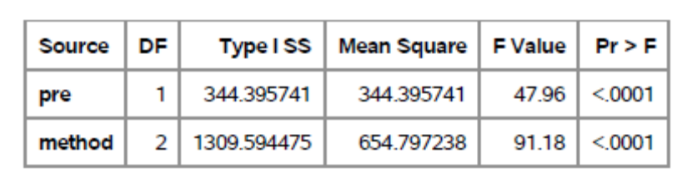

E6-a
The estimated within-group variance of E4-(a) is 545.7, which takes up approximately 30% of the total variance, while that of E5-(a) is 186.7, which takes up about 10% of the total variance. Therefore, the pre-test score is effective in reducing the error variance.

E4-a:
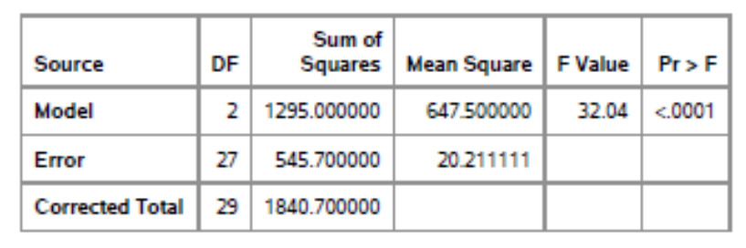
E5-a
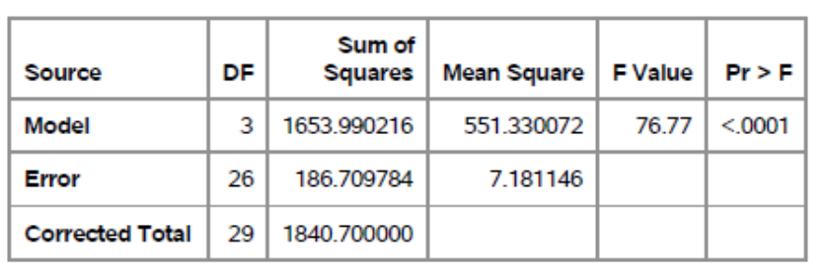

E6-b
The reduction in the error variance does affect the Tukey pairwise comparisons. Before the reduction, group means of method A and method B are not significantly different. However, after the reduction of error variance, all three groups have statistically significant different group means. This is because that by using ANCOVA, we are allowed to parcel out the effect of the covariate, which in this case is the pre-test score, and therefore, the effect of method on the dependent variable, while controlling for pre-test score, is captured in a “cleaner” way.
